The LibraryApp draws its data from MySQL based database (named bypara5_libapp). Management of the app is done over a PHPMyAdmin clone, called MyWebSQL, containing all necessary tools for administering and optimizing MySQL Databases. Tables are regular, connected in single-relation fashion between them(Primary Key from main table to single Foreign keys to other tables)

Its tables contain information about the following:

- Books: information about titles, year of publishment, ISBN code, Language etc. It is also the table on which the primary key (BookID) is the main connector to data / foreign keys into the other relevant DBtables.

- Authors: information about the relevant BookID identity of the book‘s Author (connected to “Books” table)

- Shelves: list of BookIDs as well as the shelf where each book is located

-Tags: list of BookIDs as well as relevant tags to simplify search according to theme areas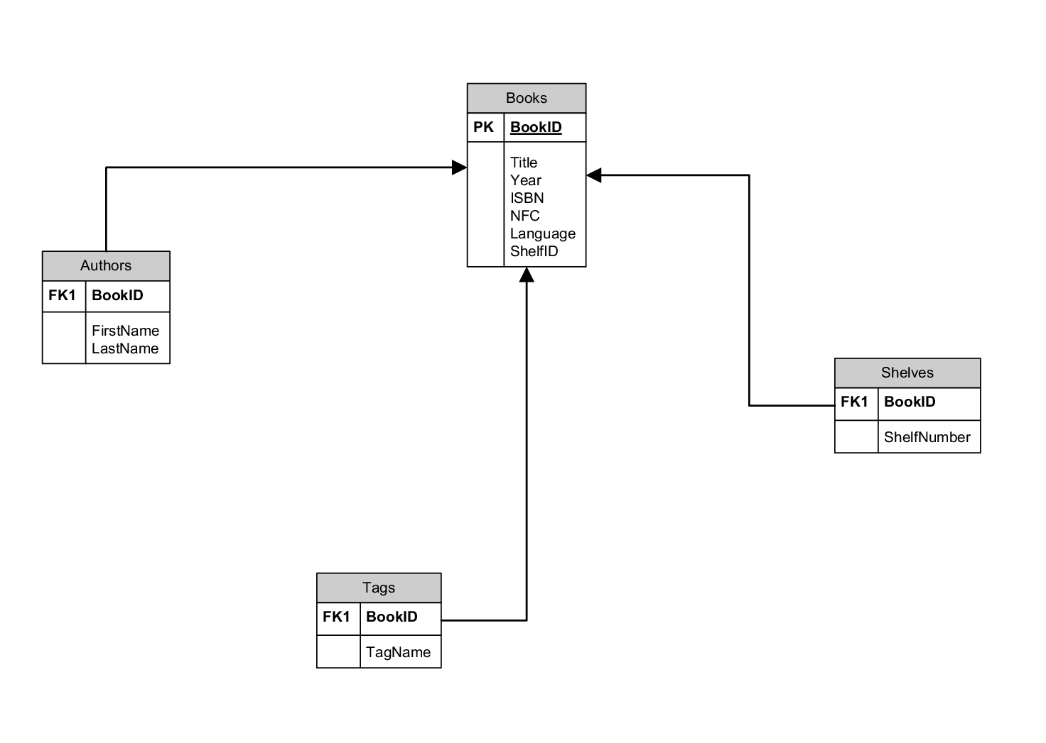

Other tables in the Database include information for different aspects of the app, such as Users for the App Administration WebGUI , Room information for assisting in classroom search (such as Room number/code, floor-building and number inside Technikum Wien, description of room usage etc.) and others. These aren’t directly connected to the LibraryApp scheme and thus not included in the above application architecture figure.